**WATER LEVEL CONTROLLER USING 555 TIMER**

**INTRODUCTION**

The drinking water crisis in India is reaching alarming proportions. It might very soon attain the nature of global crisis. Hence, it is of utmost importance to preserve water. In many houses there is unnecessary wastage of water due to overflow in overhead tanks. Automatic Water Level Controller using 555 Timer can provide a solution to this problem. The operation of water level controller works upon the fact that water conducts electricity. So water can be used to open or close a circuit. As the water level rises or falls, different circuits in the controller send different signals. These signals are used to switch ON or switch OFF the motor pump as per our requirements. So the main thing is to design and develop an automatic water level controller using 555 timer to maintain the outlet process of the water at its desired level. We need to also focuses on the need of the people to install automatic water level controller to avoid wastage of water.

**LITERATURE SURVEY**

The total amount of water available on Earth has been estimated at 1.4 billion cubic kilometers, enough to cover the planet with a layer of about 3 km. About 95% of the Earth’s water is in the oceans, which is unfit for human consumption. About 4% is locked in the polar ice caps, and the rest 1% constitutes all fresh water found in river, streams and lakes which is suitable for our consumption. A study estimated that a person in India consumes an average of 135 liters per day. This consumption would rise by 40% by the year 2025. This signifies the need to preserve our fresh water resources. The drinking water crisis in India is reaching alarming proportions. It might very soon attain the nature of global crisis. Hence, it is of utmost importance to preserve water. In many houses there is unnecessary wastage of water due to overflow in overhead tanks. Automatic Water Level Controller using 555 Timer can provide a solution to this problem. The operation of water level controller works upon the fact that water conducts electricity. So water can be used to open or close a circuit. As the water level rises or falls, different circuits in the controller send different signals. These signals are used to switch ON or switch OFF the motor pump as per our requirements. So the main thing is to design and develop an automatic water level controller using 555 timer to maintain the outlet process of the water at its desired level. We need to also focus on the need of the people to install automatic water level controller to avoid wastage of water.

**THEORITICAL ANALYSIS**

**Block diagram**

Power Supply

s

Transistor

Bc548

IC

555

Bc548

Transistor

Relay

Water Tank

Ac Motor 230v

Switch

IN 4007 Diode

**EXPERIMENTAL INVESTIGATIONS**

As shown in the above block diagram gives the information about this particular water level controller.

It consist of BC 548 Transistor, LM555 IC Timer, Relay, Diode, Motor, and a Tank which can be used to fill the water.

When the input 6v-12v is given from battery/power supply to the project start working.

The input is given from power supply then the transistor will active through the relay the power is supplied to the IC 555 timer.

The output pin of the IC 555 timer is connected to the relay and the diode.

Then the relay is maintained at a required level and the motor will be start up by switching ON. When the motor is ON its ready to fill the tank by recognizing the sensors or water level in the tank.

It is depend up on the level of water.

When the water is full then automatically it gets switched OFF.

**FLOW CHART** 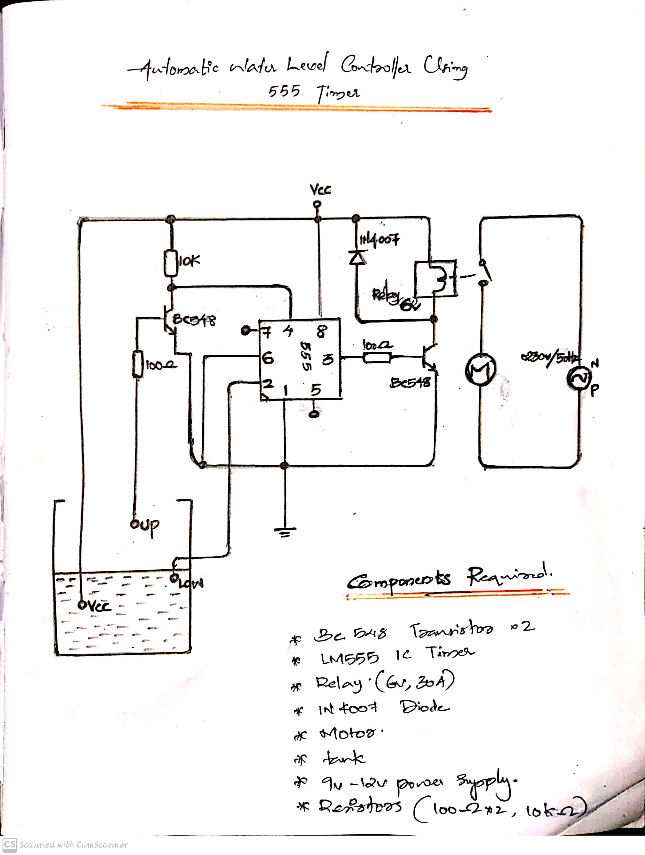

**RESULT**

**TEST POINT 1**

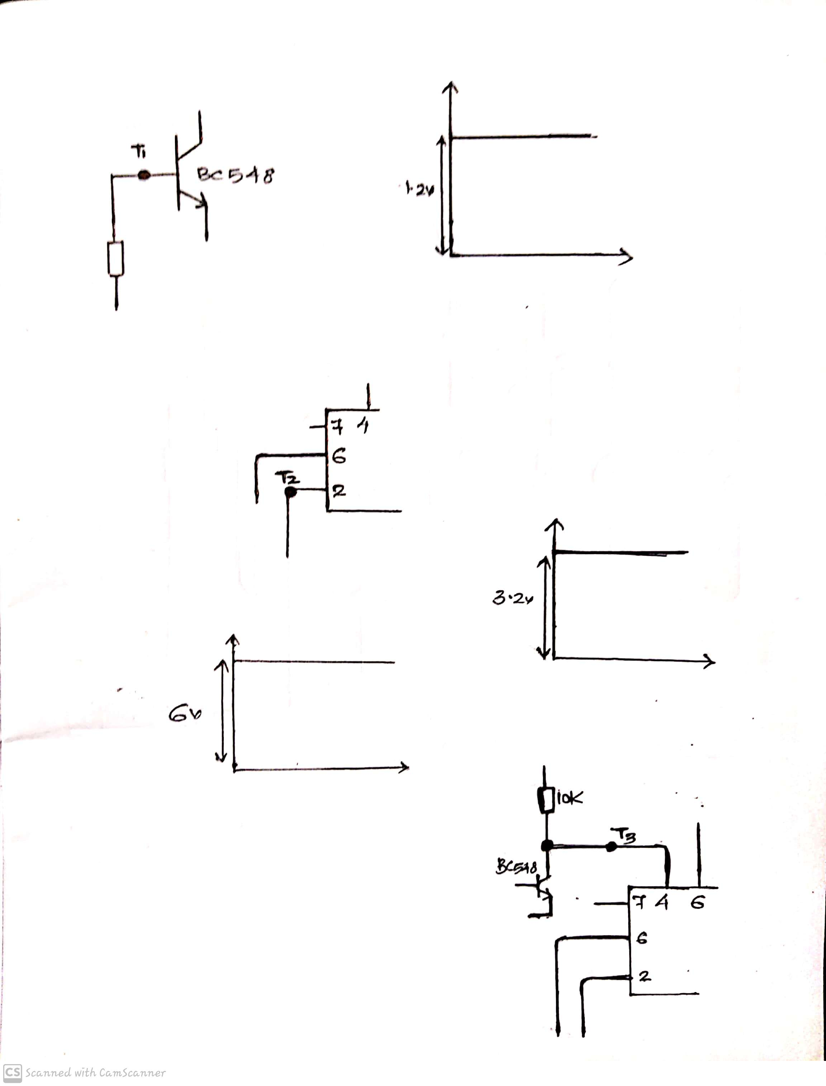Base of Q1 is connected to up level of water through a resistor R1(100ohm). It will be at high voltage (vcc drop across R1). All other condition it will zero volts i.e. no connection.

* **Test Point 1 Reading**

It is measured out across the positive end of CRO towards base of transistor Q1 and negative end at ground level. The obtained output is

TANK IS EMPTY, BELOW UP LEVEL, LOW LEVEL : No voltage (no connection)

**TANK IS FULL**



**TEST POINT 2**

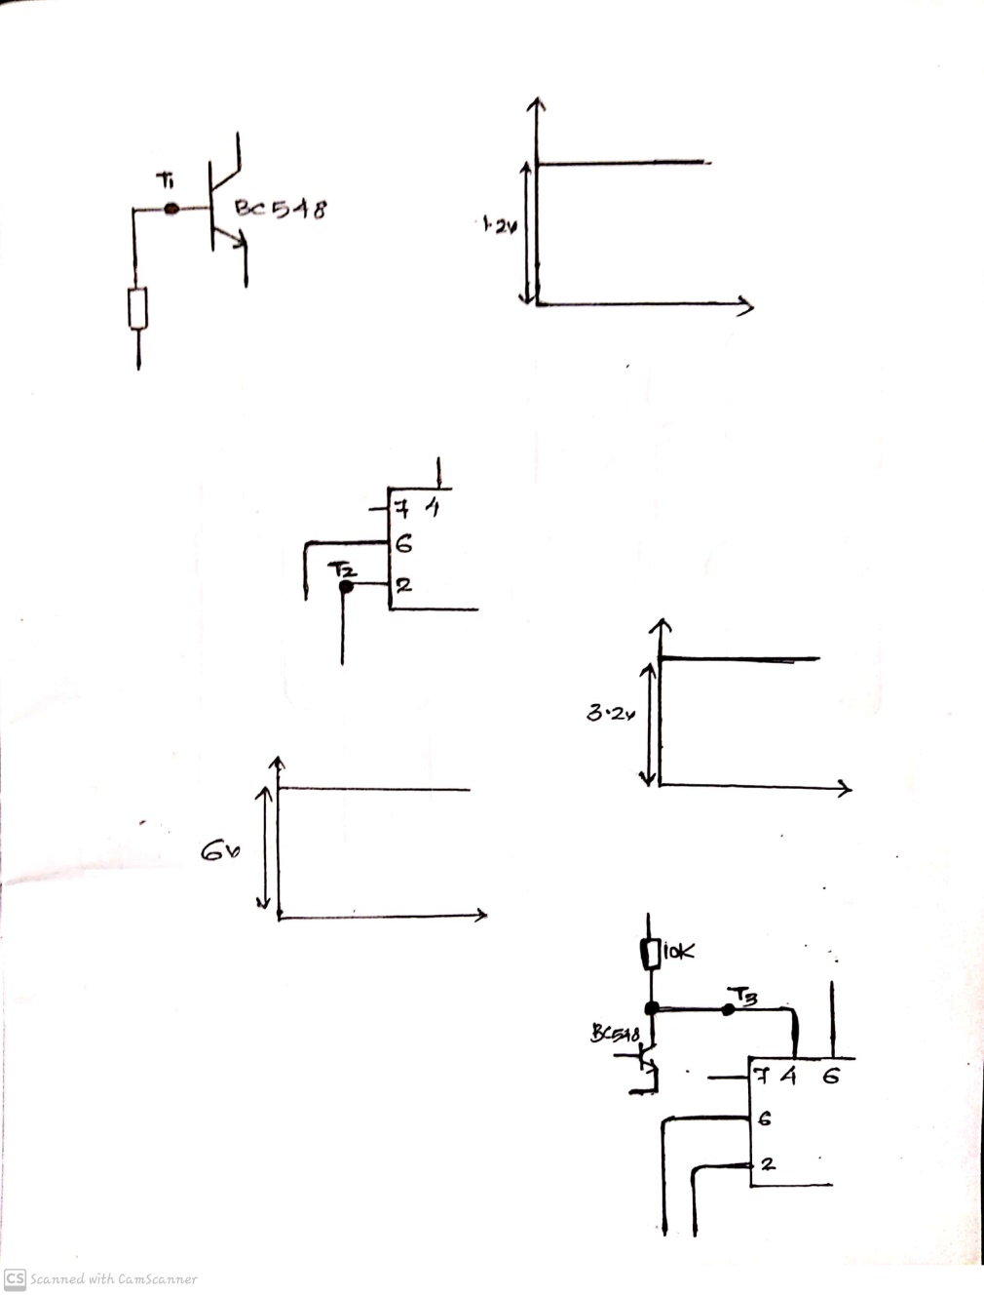

* **Test Point 2 Reading**

It is measured across the positive end of CRO towards pin 2 of IC 555 and negative end at ground level.

TANK IS EMPTY AND BELOW LOW LEVEL:0v

**FULL**



**BELOW UP LEVEL**



**TEST POINT 3**



*T3: reset input of 555 timer*

It is connected to collector of Q1. It will be at high level when the water level is below up level. When the water level reaches the up level Q1 will conduct and T3 becomes low. It will reset the 555 timer output and motor will set OFF.

* **TEST POINT 3 READING**

It is measured out across the positive end of CRO towards pin4 of IC 555 and negative end at ground level.

The output obtained is

TANK IS EMPTY, BELOW UP LEVEL:6v AND TANK IS FULL:0v



**TEST POINT 4**

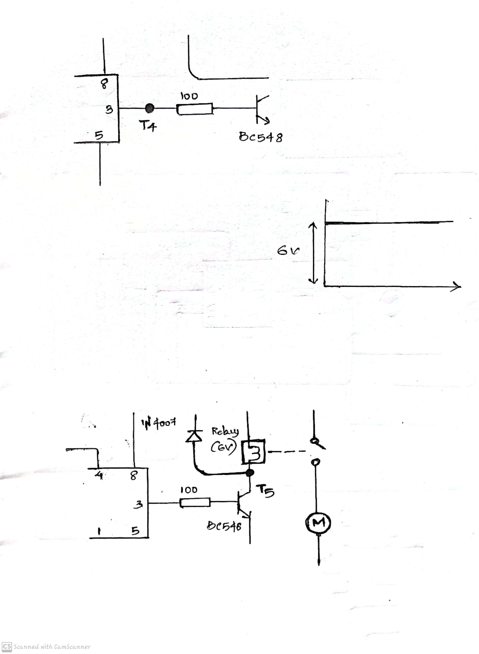

*T4: output of 555 timer*

This signal will go high whenever water level goes below the low level and will get reset when water level goes above up level.

* **Test Point 4 Reading**

It is measured out across the positive end of CRO towards pin 3 of IC 555 and negative end at the ground level.

TANK IS BELOW UP LEVEL AND FULL LEVEL IS: 0v

TANK IS EMPTY, TANK IS BELOW LOW LEVEL: 6v



**TEST POINT 5**



*T5:collector of Q2*

This is connected to VCC and relay. When water goes below the low level 555 timer will set output and it will turn ON Q2 transistor. T5 point will become low. Otherwise, it will be high.

* **Test Point 5 Reading**

It is measured out across the positive end of CRO towards collector of transistor Q2 and negative end at ground level

TANK IS EMPTY: 0v

TANK IS FULL, BELOW UP AND LOW LEVEL: 6v

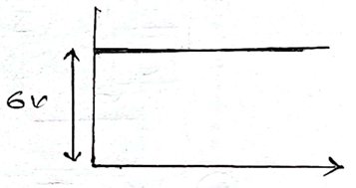

**SCHEMATIC DESIGN**

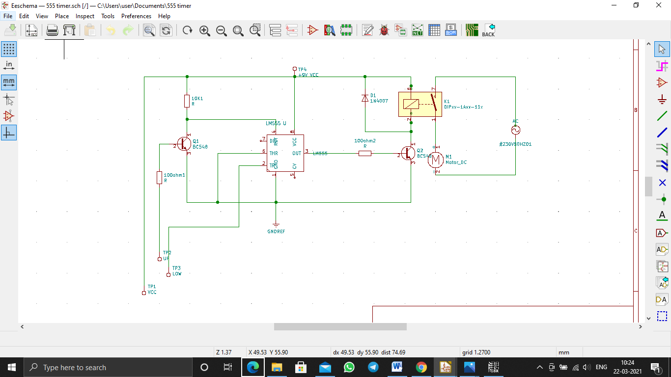

**PCB LAYOUT**

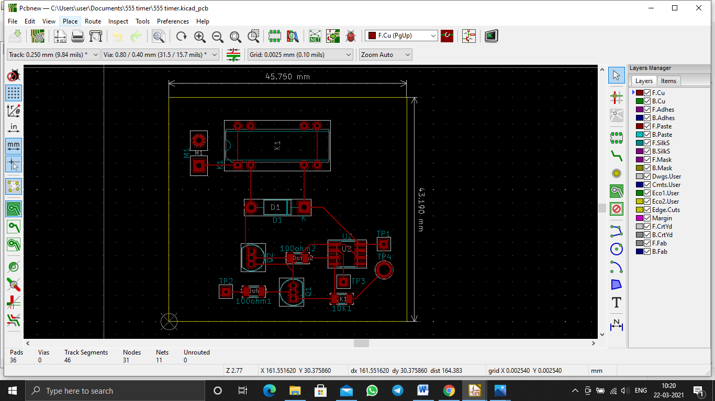

**3D VIEW**

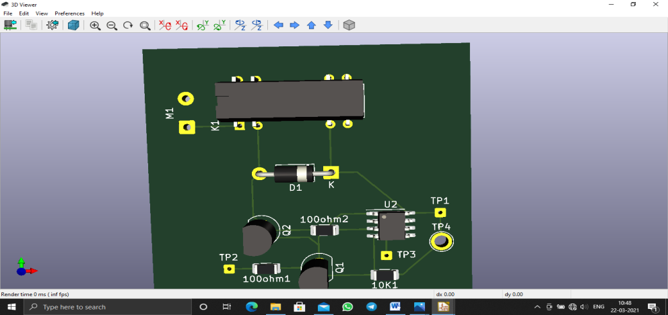

**GERBER DESIGN**

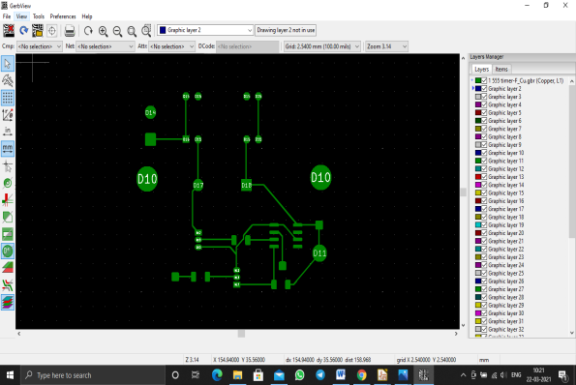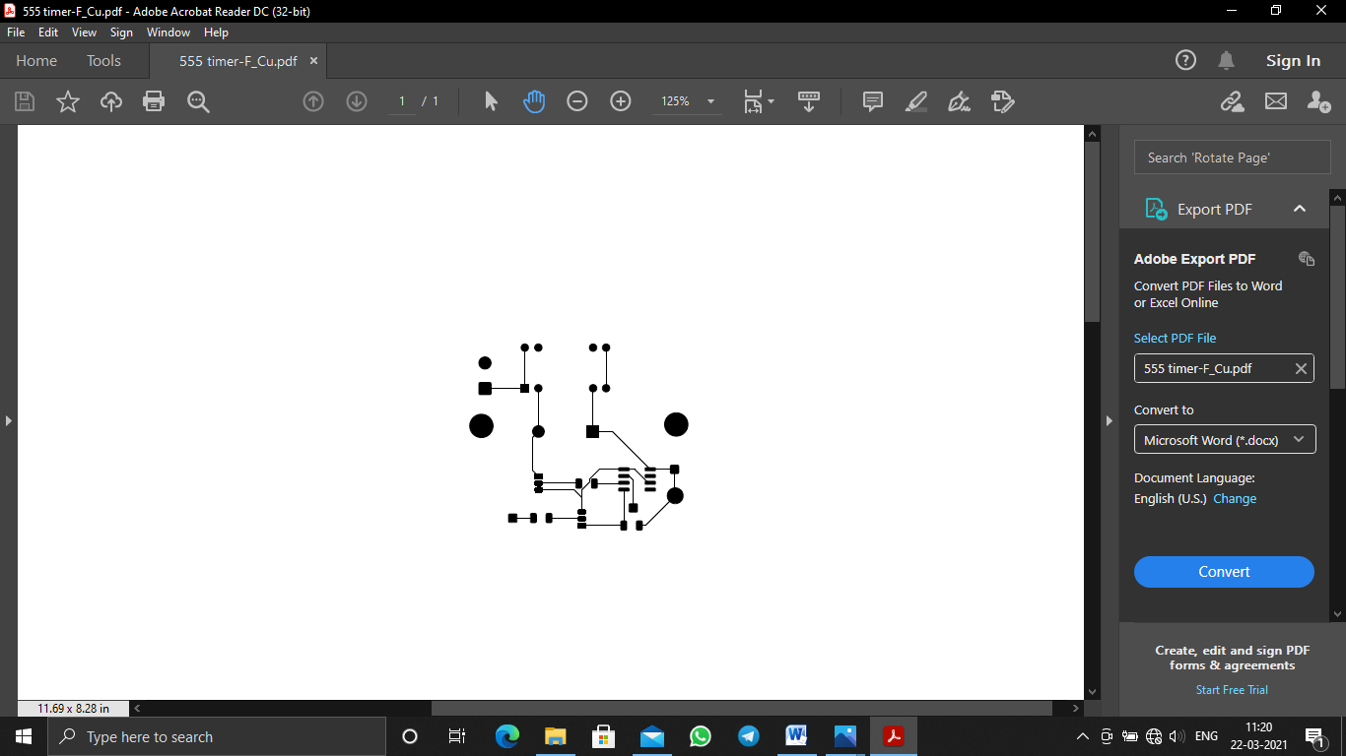

**APPLICATION**

* It is used for all household purposes.
* It can be used in commercial centers.
* It will be very much useful to farmers to store large amount of water.
* It can be used in all places to control water level.

**ADVANTAGES**

* Low maintenance.
* Compact and good design.
* Fully automatic.
* Saves water, energy.
* Increases pump life.

**DISADVANTAGES**

* This project may not be able to handle high power.
* The components used in this are sensitive and may damage easily.
* We need to insert the wire in accordance with the level of water.

**CONCLUSION**

In these days, when Earths reserve of consumable water is decreasing every moment, every drop has its value. Water level controller is a simple yet effective way to prevent wastage of water. Its simplicity in design and low components make it an ideal piece of technology for the common man.

Thus the automatic water level is a big boon as concerned with the house hold applications as well as other water saving purposes including agricultural sector and industries. Based on the survey result, it is found that the automatic water level controller has a rising and it is a good asset from the electronics perspectives.

Hence we conclude that,

* This system is very beneficial in rural as well as urban areas.
* It helps in the efficient utilization of available water sources.
* If used on a large, it can provide a major contribution in the conservation of water for us and the future generations.

**BIBLIOGRAPHY**

* [www.electronicshub.org](http://www.electronicshub.org)
* P.S Bimbhra,”Power Electronics”,khanna publication.
* V.K Mehta and Rohit Mehta (2013),”Principles of Power System”, S.Chand.
* V.K Mehta(2012),”Principles of Electrical Engineering and Electronics”, S Chand.
* Bird,John(2010),”Electrical and Electronics Principle and Technology.
* Rex Niedermeyer ”Aquarium Water Pump”.